Anisha Aggarwal

Homework #3

**Magazine Word-Find Algorithm**

1. Write down a phrase for the computer to find
2. Tell the computer the first letter for which the computer must search for in the magazine
3. The computer must read it from first page to last, top to bottom, left to right
4. Compare the variable to each letter being read in the magazine
   1. If the letters are not a match (to either the capital or lower case), then move on to the next letter
   2. Else (if the letters do match), circle the letter and write down the page number
5. Once the first letter is found, move on the next letter and repeat steps 3-4 for that letter
6. Repeat step 5 until there are no letters left for the computer to find

**Magazine Word-Find Flowchart**

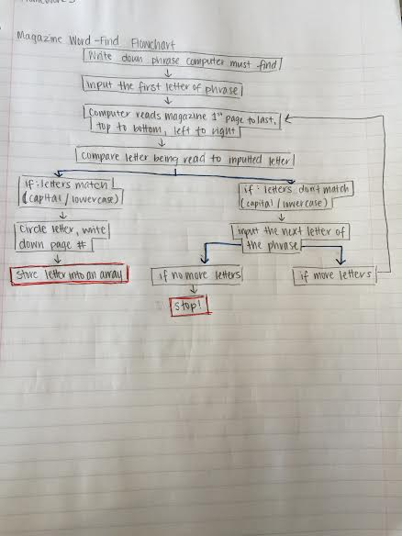

**Comparison of If/Else statements of SLiK and C++**

One similarity is that the “if” and the “else” have to line up and the “body” is indented. Another similarity is that the “conditional” goes directly after the “if”.

A difference is that in SLiK there is a “then” that is written after the “conditional”, while in C++ there is no ”then”. Another difference is that in C++ the conditional is written within parentheses while in SLiK it is just stated. The last difference is that there are curly brackets around the body in C++ in order to tell where the body will start and stop, where as in SLiK the way to tell that the body ends with an “endif”.

**Chapter 3 “Review Questions” (5-10)**

5. The structure that tests a condition, takes action if the result is true, and then tests the condition again can be called all of the following except a(n) if-then-else.

6. Placing a structure within another structure is called nesting.

7. Attaching structures end to end is called stacking.

8. When an action is required if a condition is true, but no action is needed if it is false, you use a single-alternative selection.

9. To take action as long as a condition remains true, you use a loop.

10. When you must preform one action when a condition is true and a different one when it is false, you use a dual-alternative selection.

**Chapter 4 “Review Questions” (2-7, 9-10, 18-20)**

2. In a selection, the else clause executes when the tested condition is false.

3. The greater-than operator evaluates as true when the left operand is greater than the right operand.

4. A trivial Boolean expression is one that is always false.

5. If x <= y is true, then x > y is false.

6. If j <> is true, then both b and c are true.

7. In an AND condition, the most efficient technique is to first ask the question that is least likely to be true.

9. If p is true and q is false, then p or q is true.

10. Which of the lettered choices is equivalent to the following decisions? d

if x > 10 then

if y > 10 then

output “X”

endif

endif

18. If sales = 100, rate = 0.10, and expenses = 50, which of the following expressions is true? a

19. If a is true, b is true, and c is false, which of the following expression is true? c

20. If d is true, e is false, and f is false, which of the following expressions is true? c